**Mild to Moderate evaluation**

Sample_ID: **AXVRDJ (Cat)**

Link**: https://release.animalbiome.com/pet/assessment/report/0d0ac4bd-7f25-49e0-8c87-fdc8ab210b5a**

Cats and dogs:

Any Two

(High Yellow Flag Megamonas OR (failed)

High Yellow Flag Sutterella OR (failed)

High Yellow Flag Collinsella OR (failed)

Low Yellow Flag Bacteroides OR (**passed**)

Low Yellow Flag Blautia (**passed**)

)

OR

OR Cats: 8-10 Yellow Flags (**passed**)

OR 5-8 Red Flags; (failed)

OR diet recommendation of increase fibre (**passed**)

OR diet recommendation of increase protein (failed)

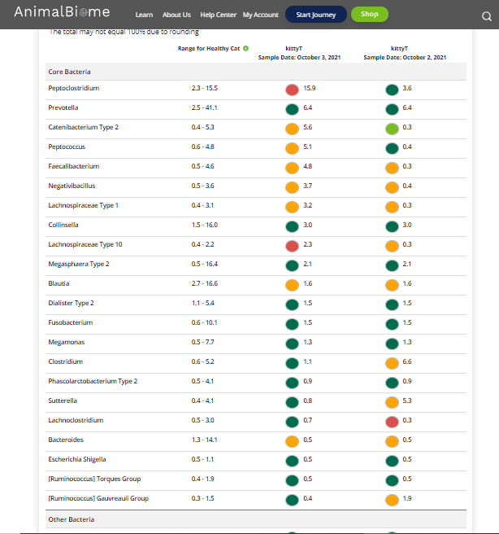



The result : **True True False True.**

Expected result : Mild to moderate

Acheived result : **passed**.

